POWERBI DASHBOARD PERFORMANCE ANALYZING AND STORYTELLING
Checked data types of all columns and changed the data type of Quantity from Decimal to Whole number:
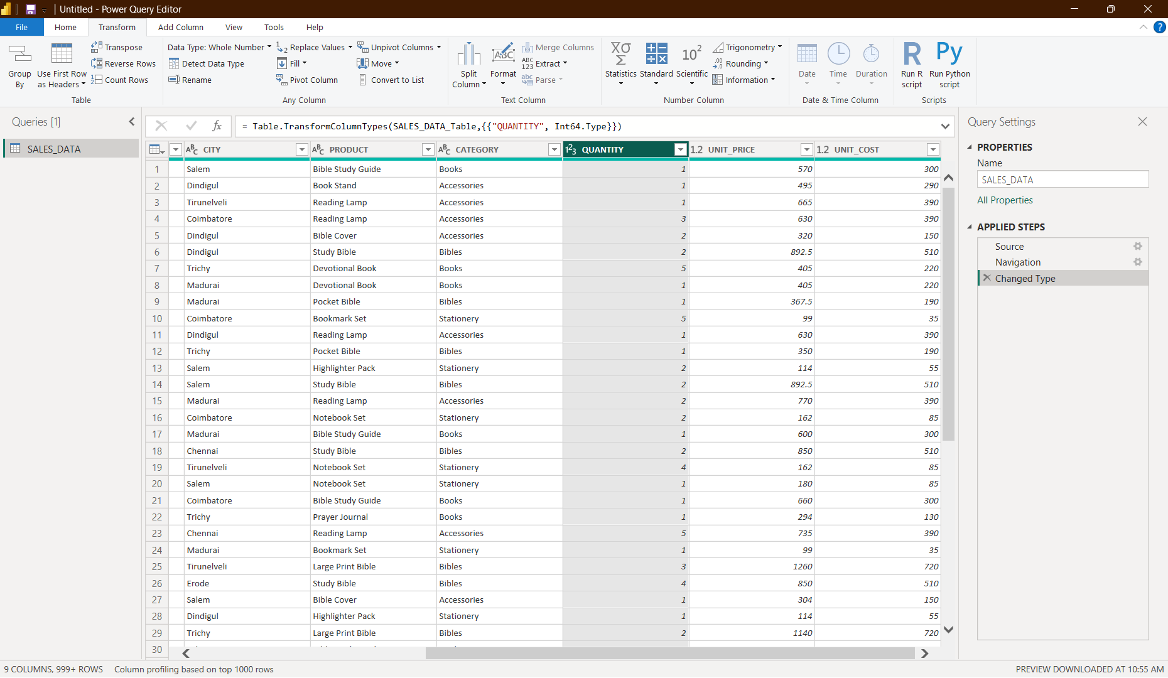
Chose Click and Apply from Home tab.
Inserted a new column(Sales amount):
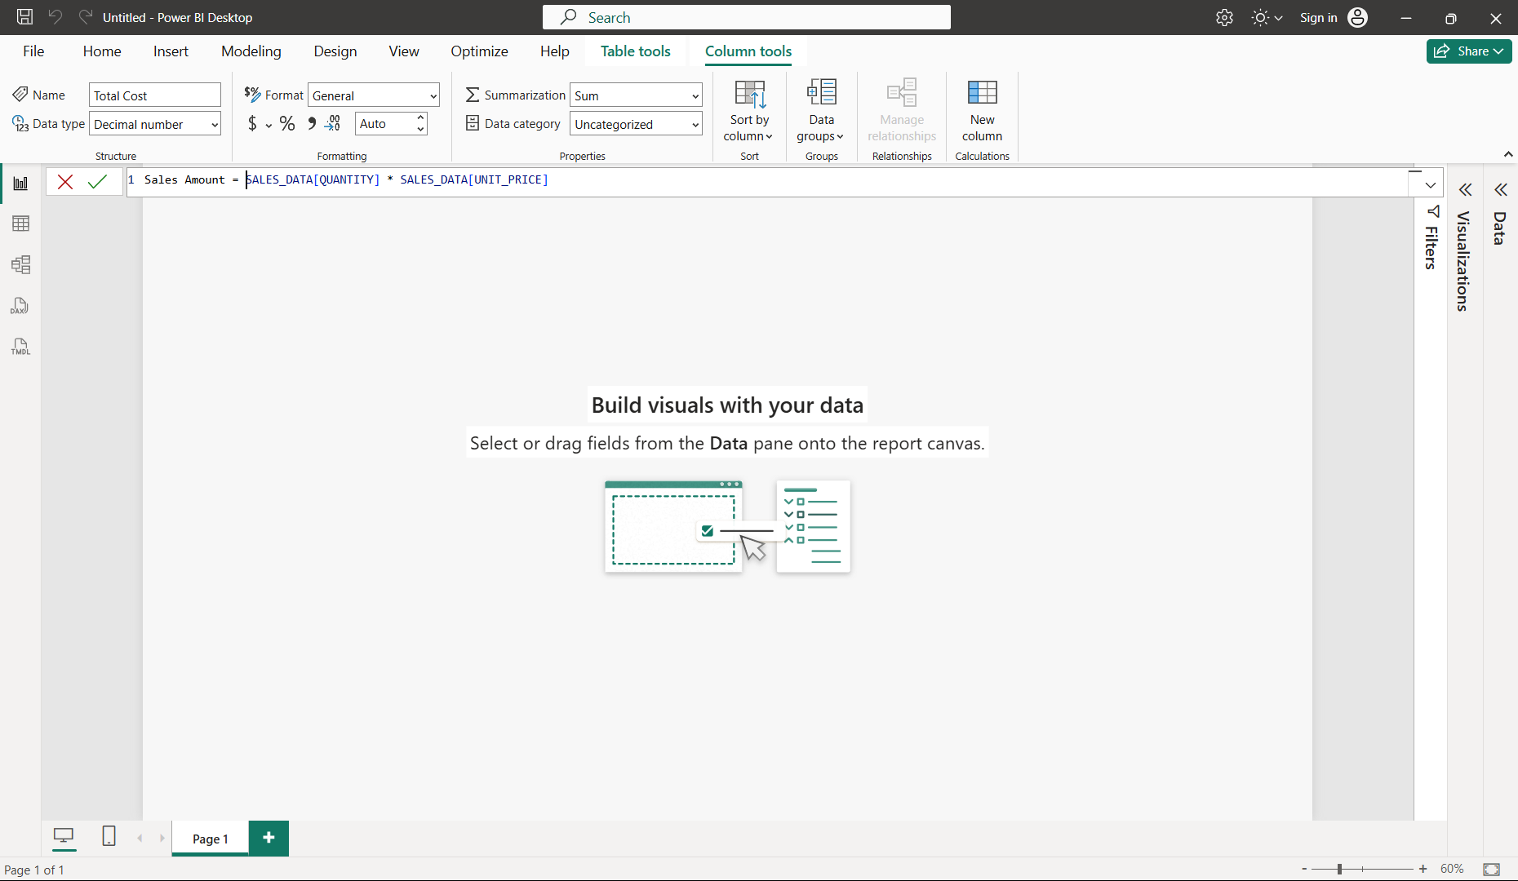
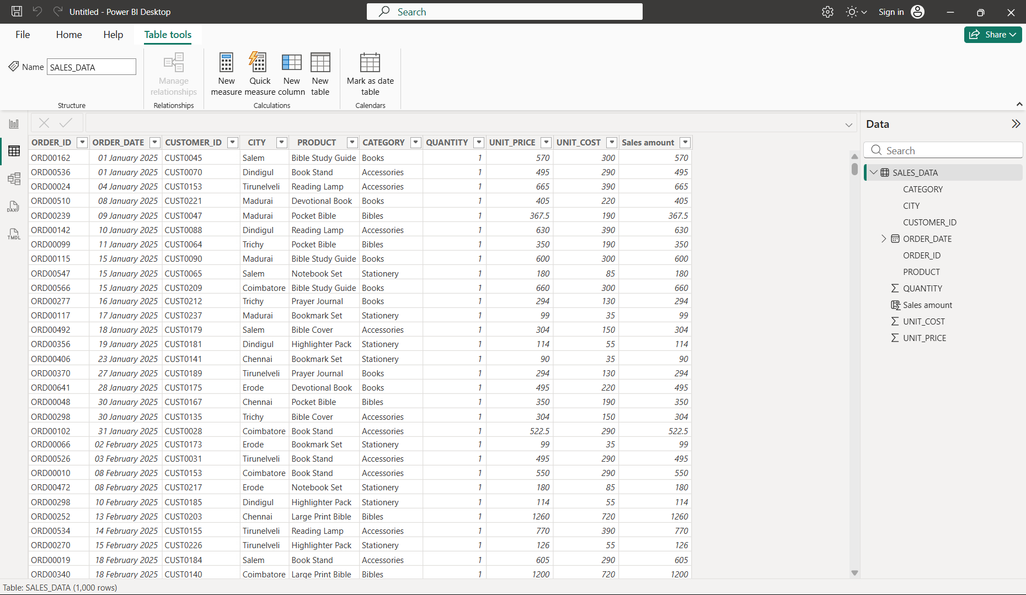
New Column Total Cost:
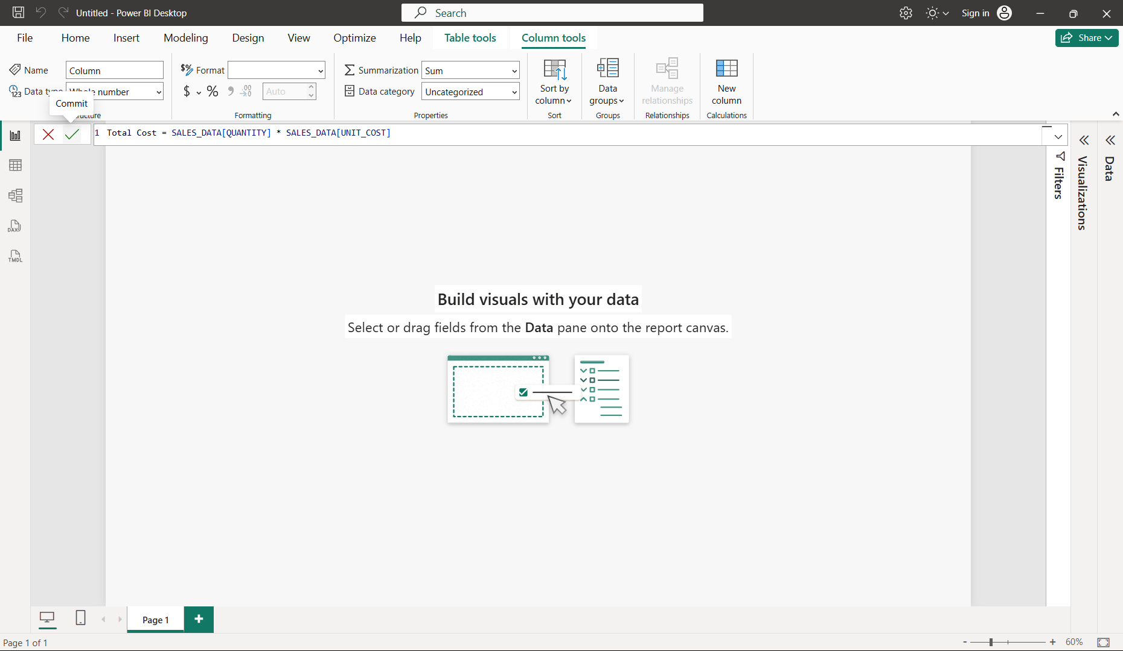
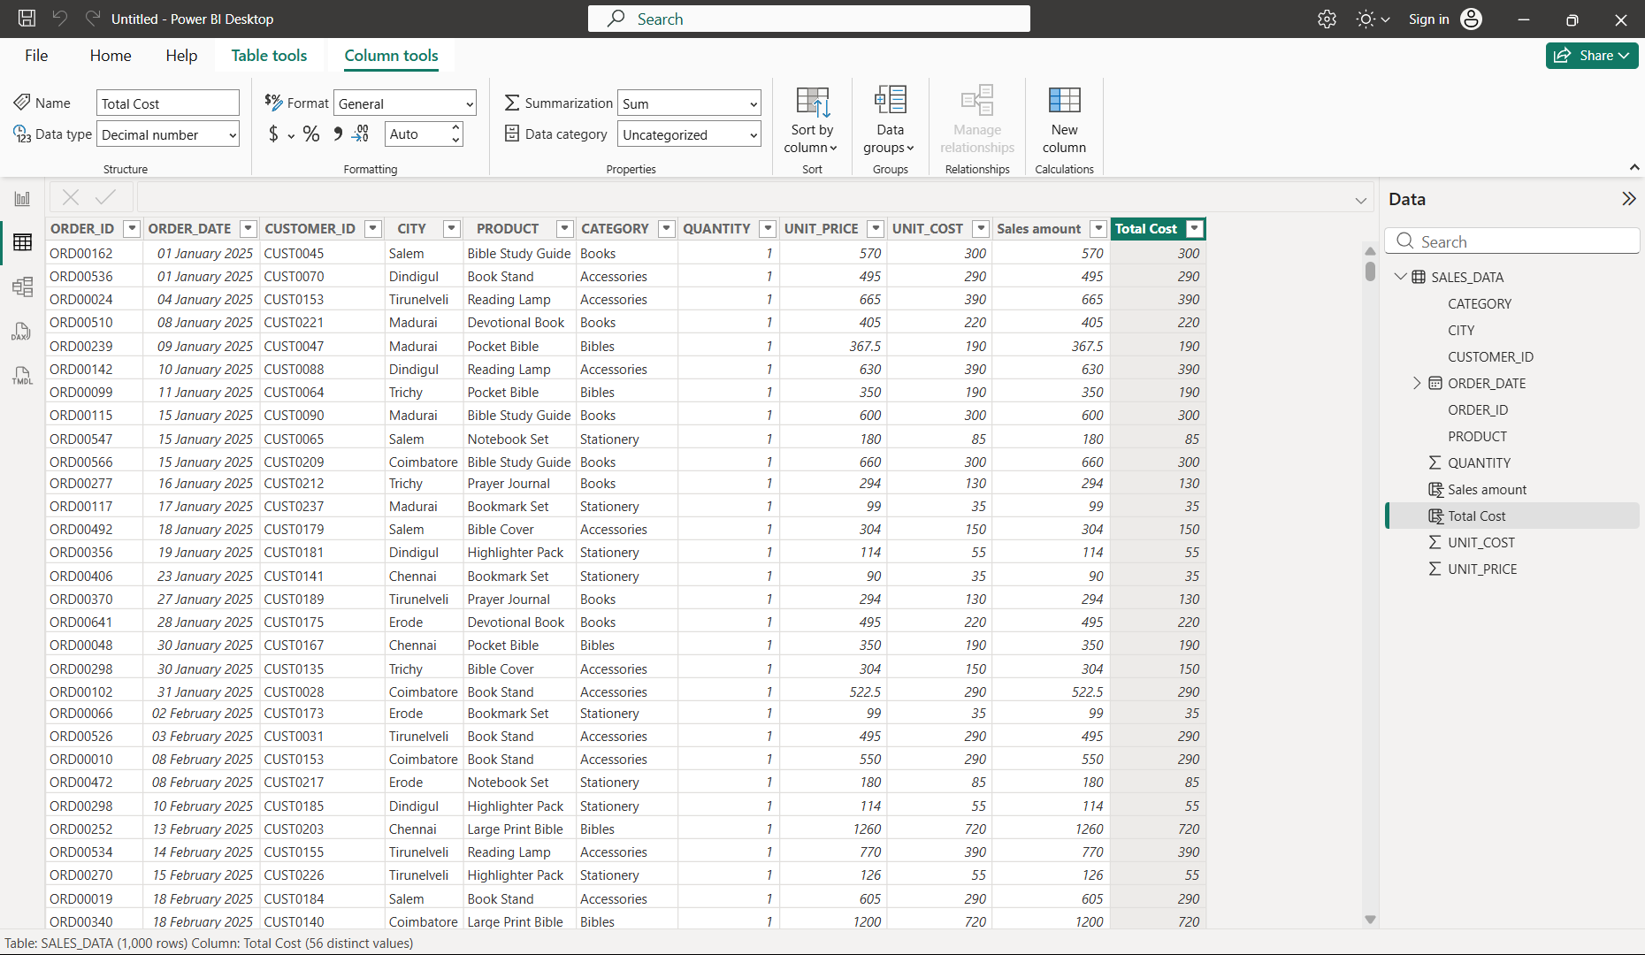
New Column Gross Profit:
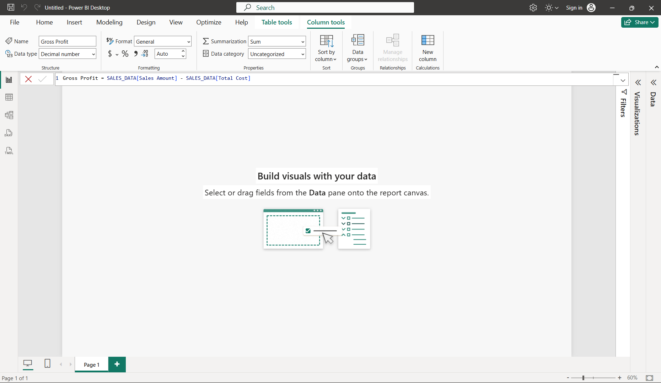
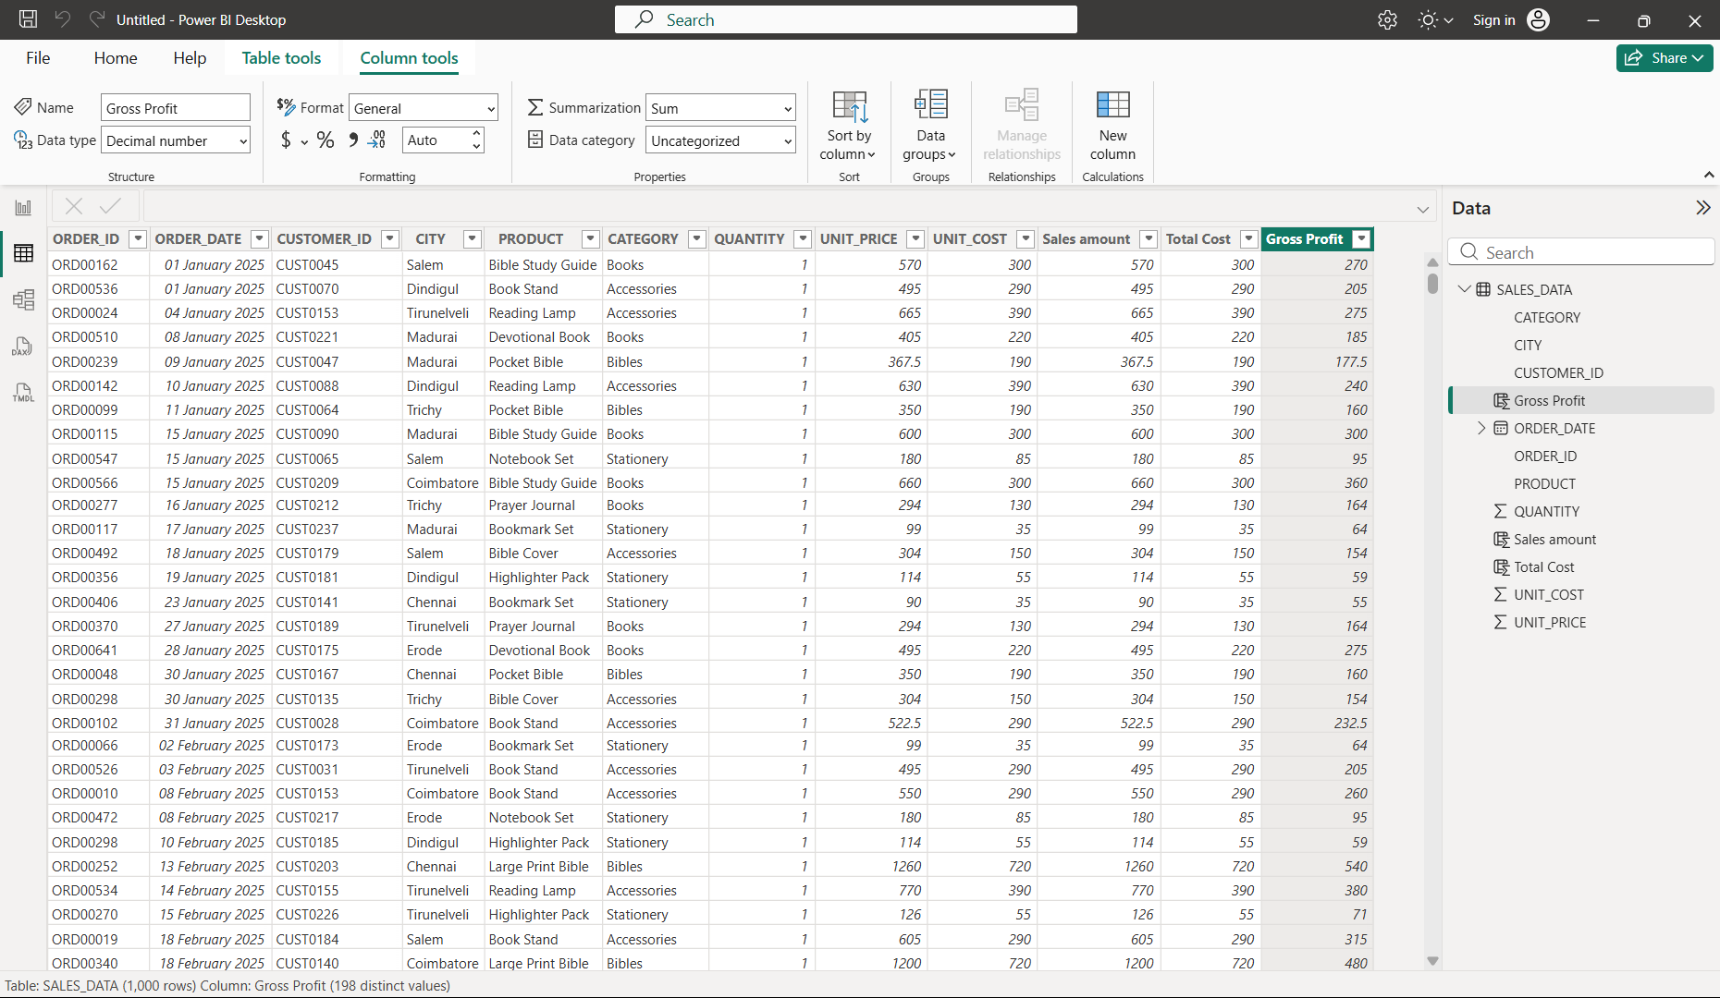
New column Profit category:
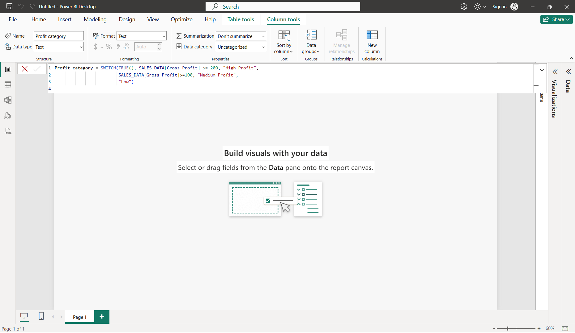
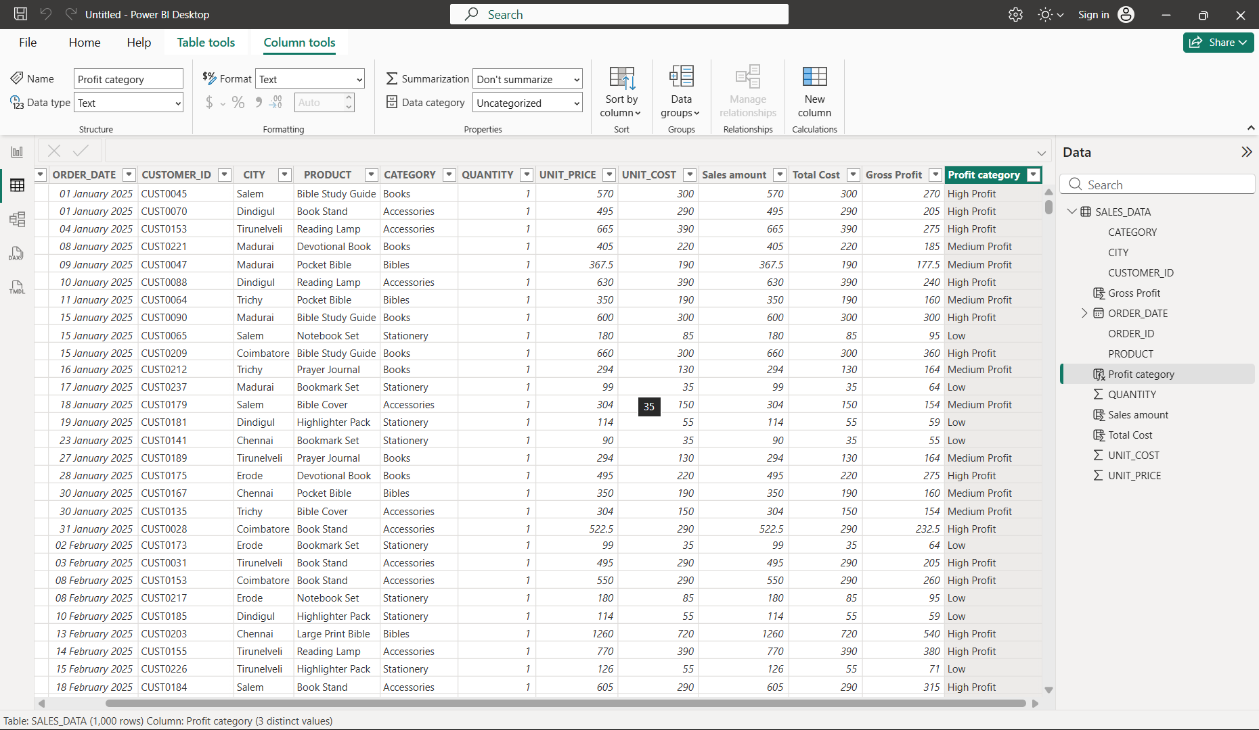
New measures created:
- 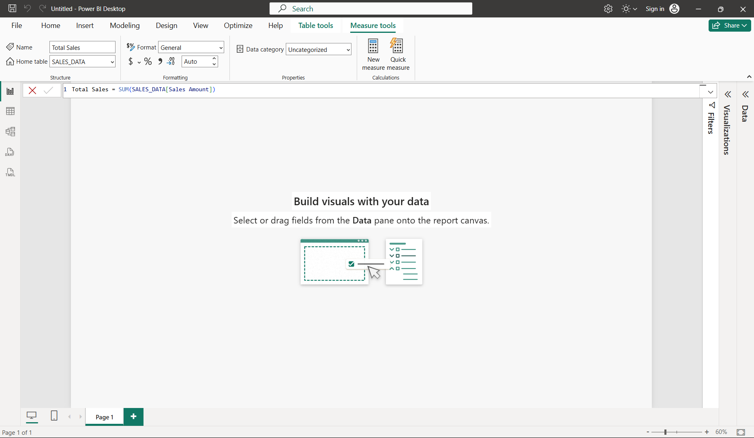
- 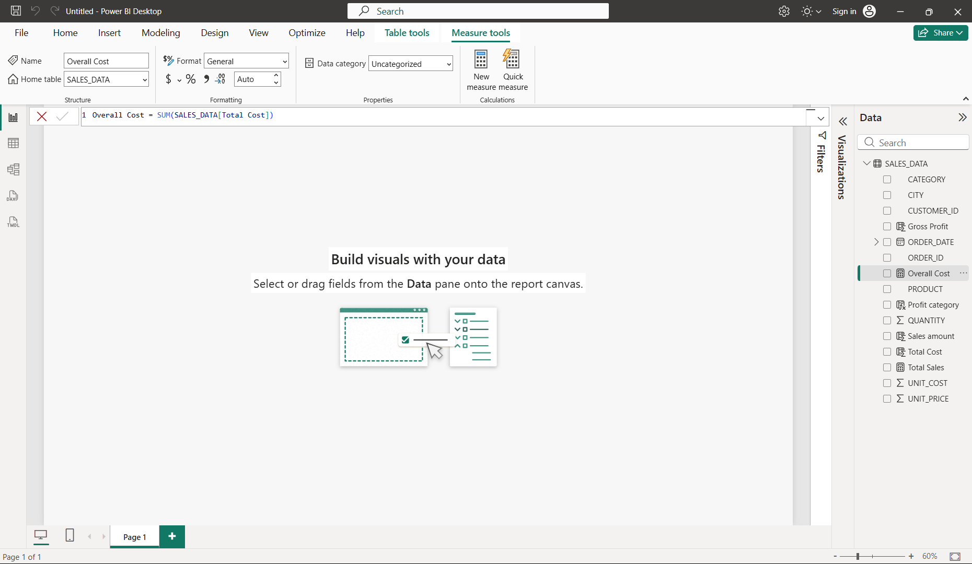
- 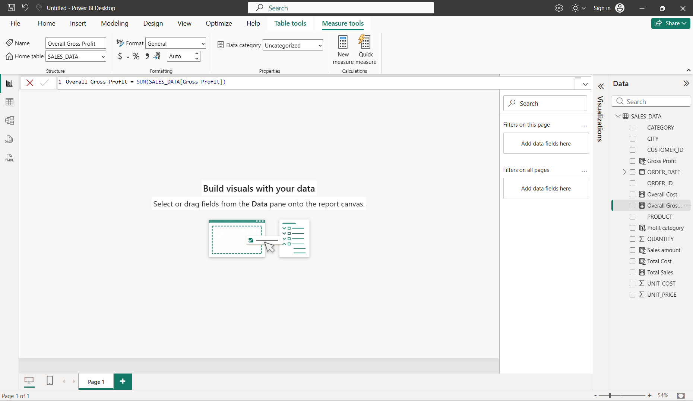
- 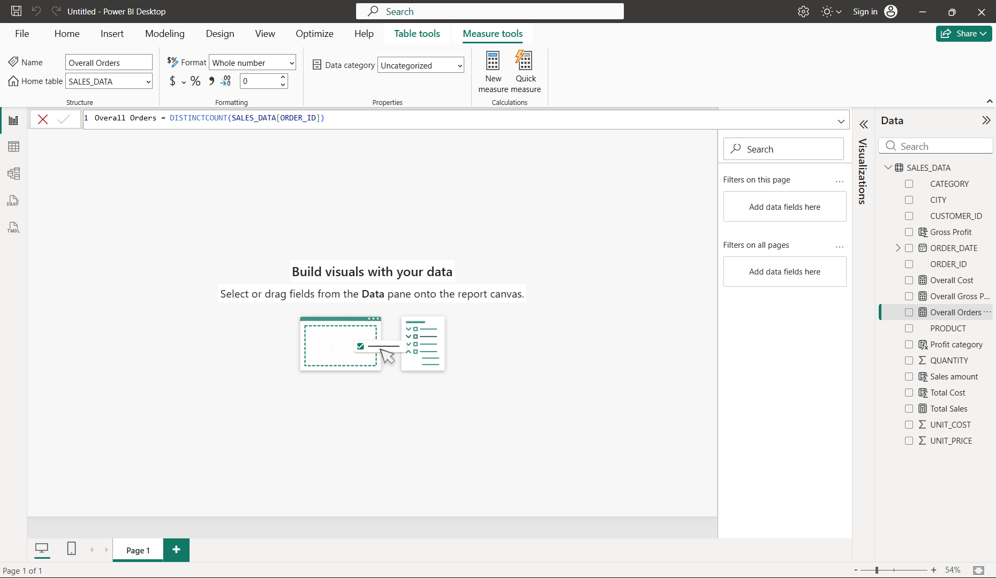
- 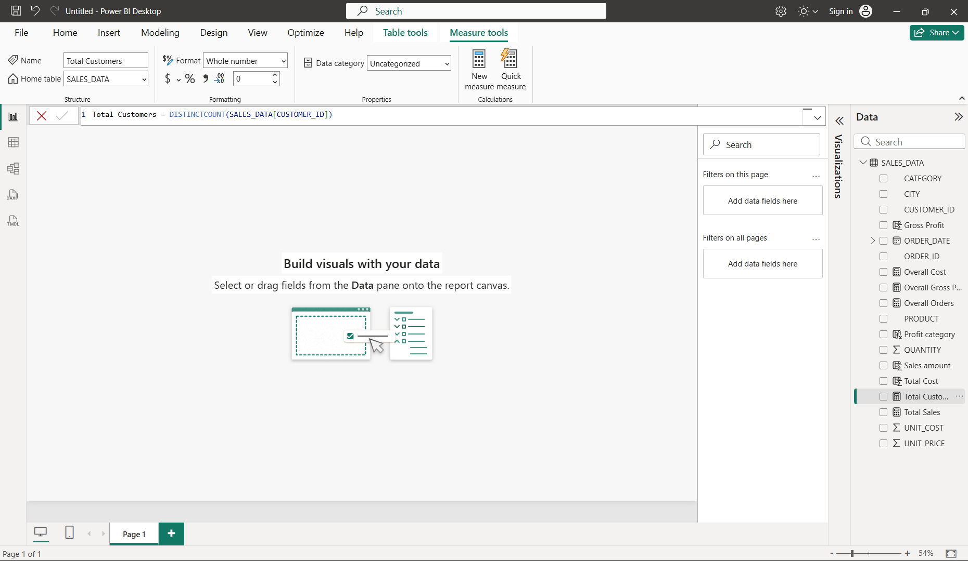
- 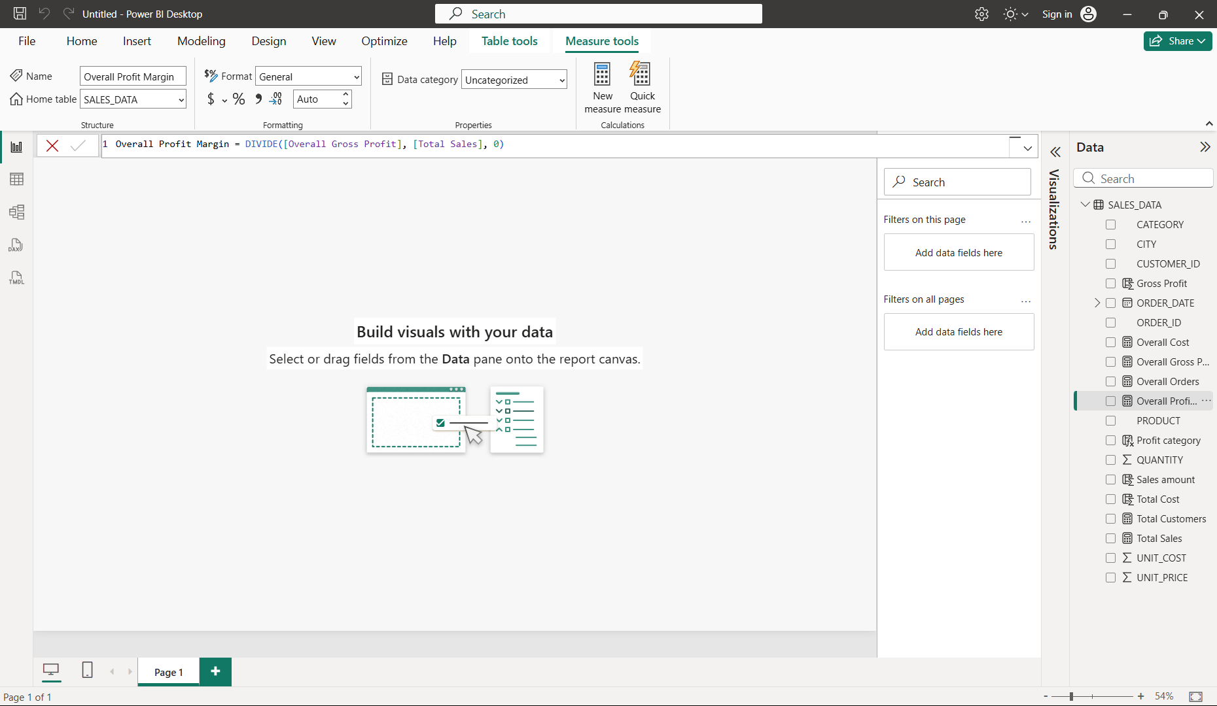
- 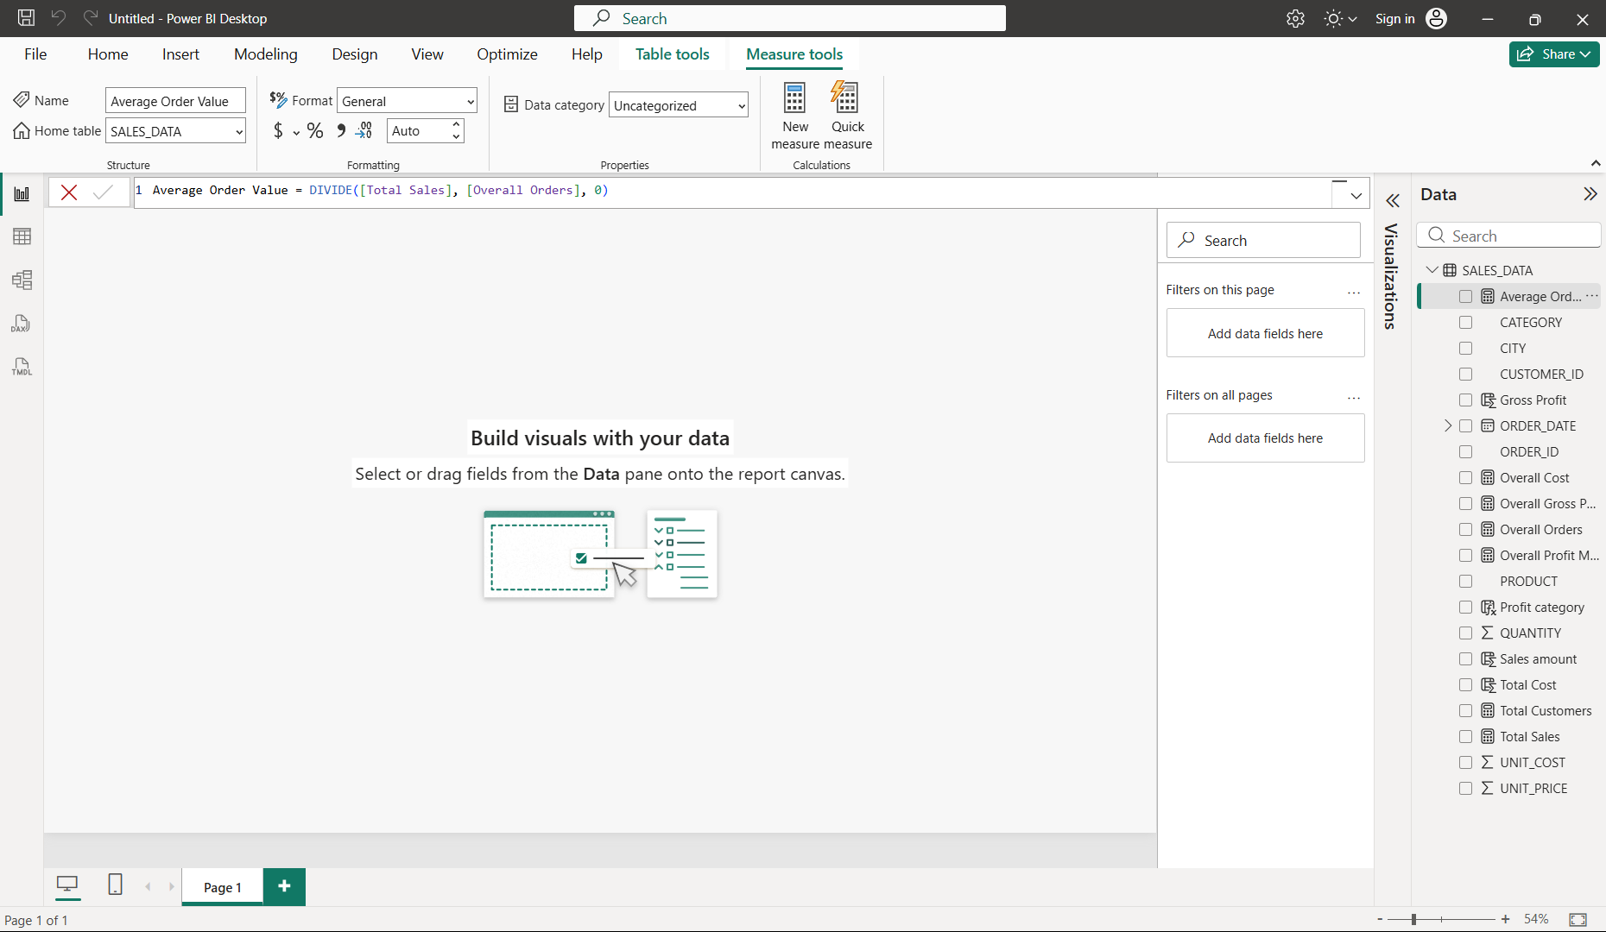
- 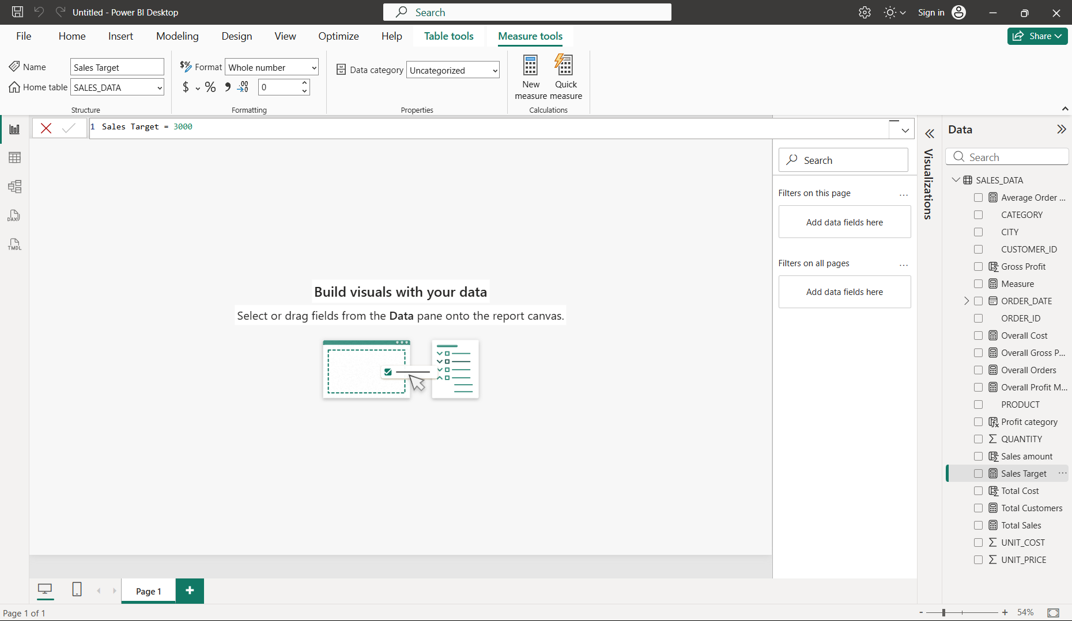
- 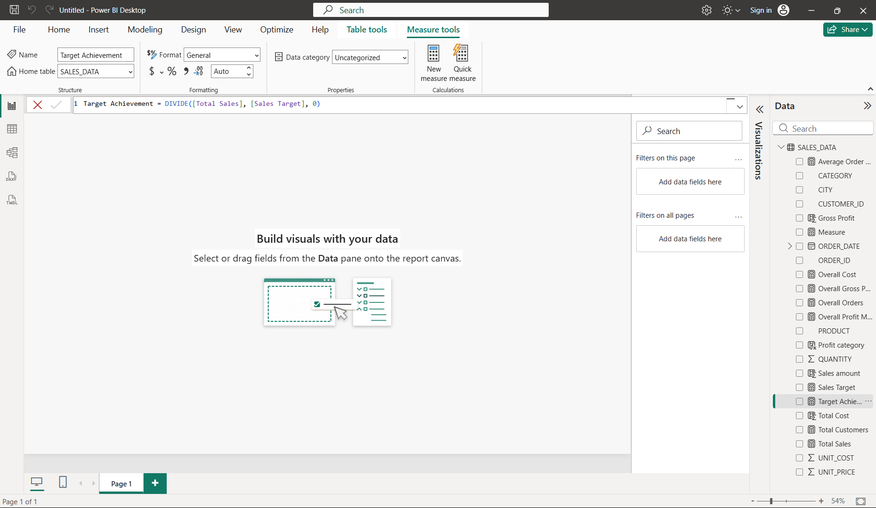
- 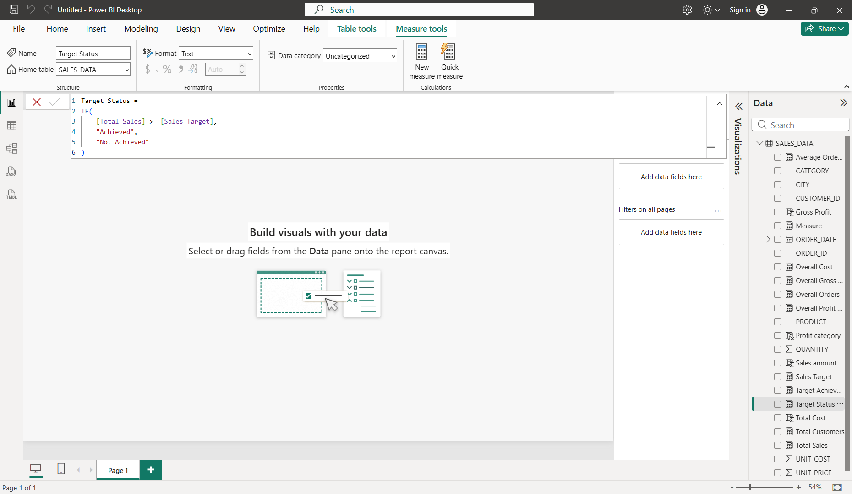
Table view:
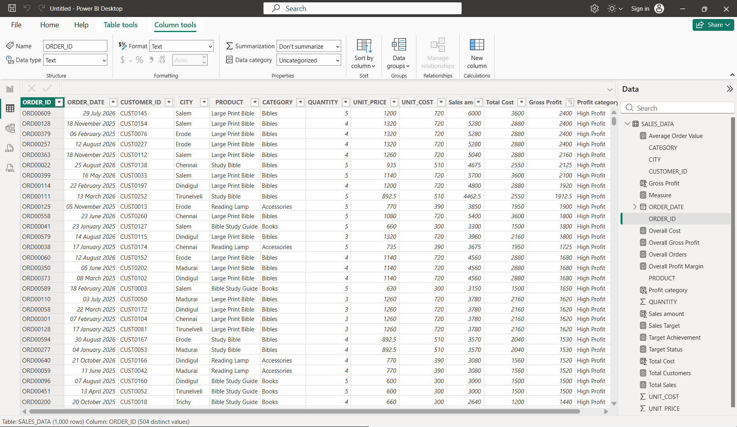

Report view:
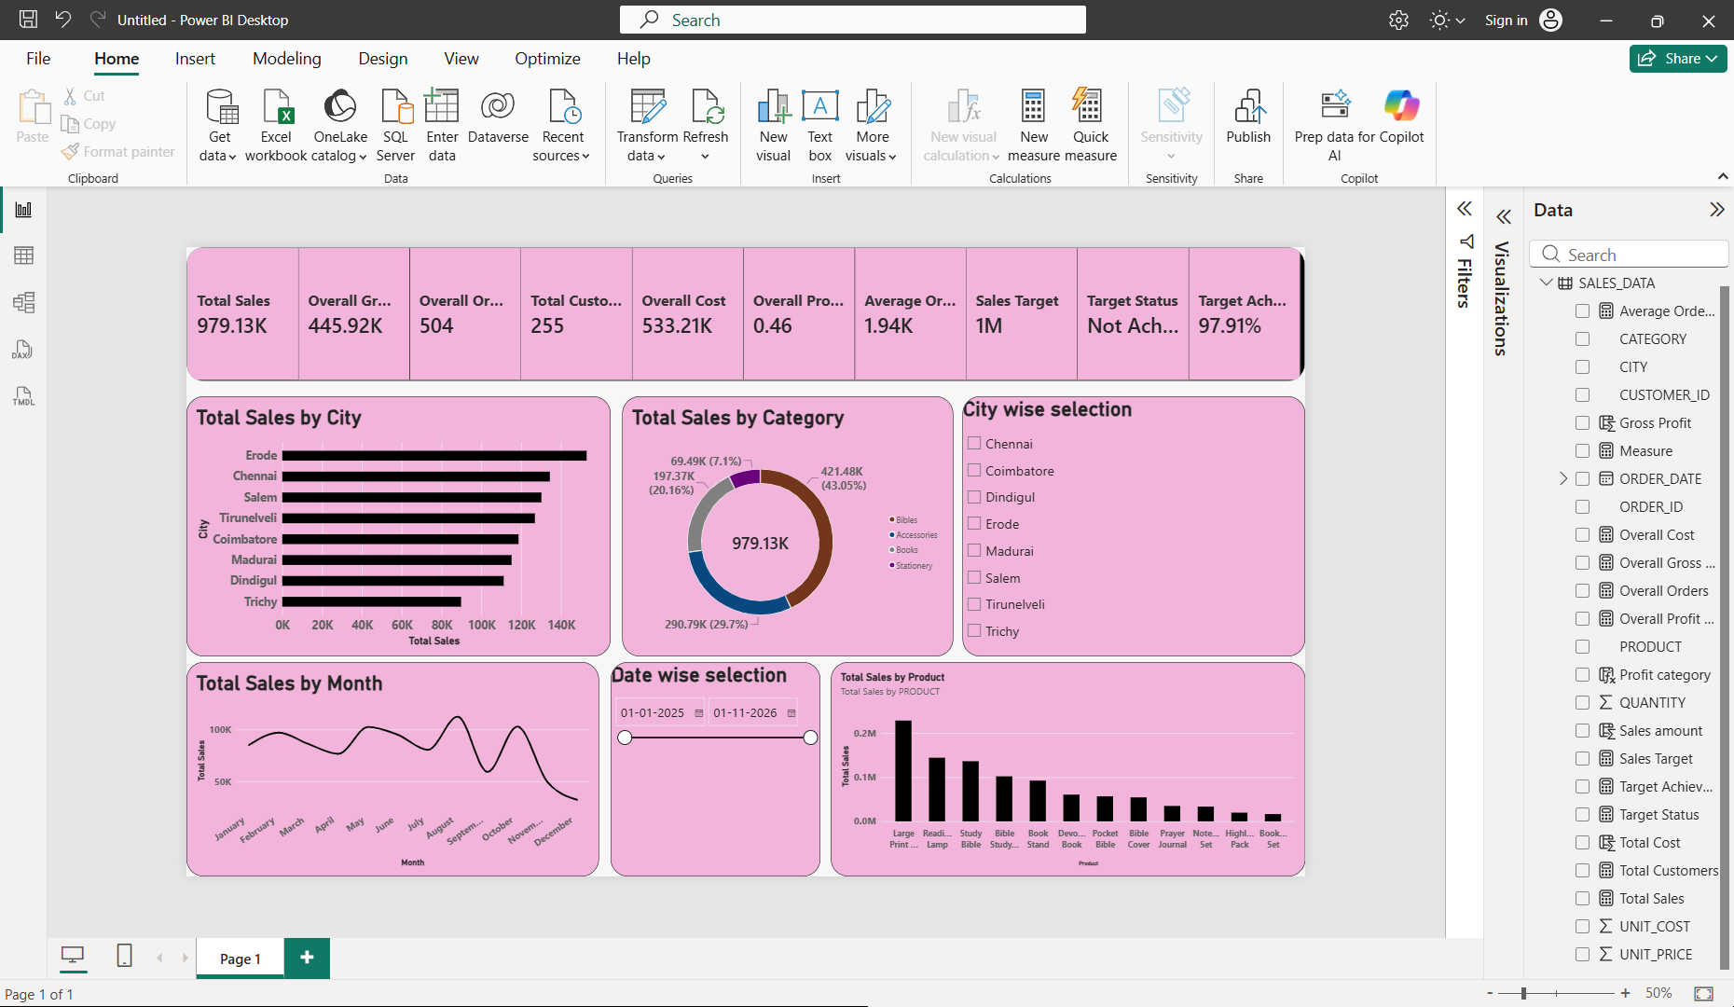
Tried hide view for UNIT_COST column in table view:
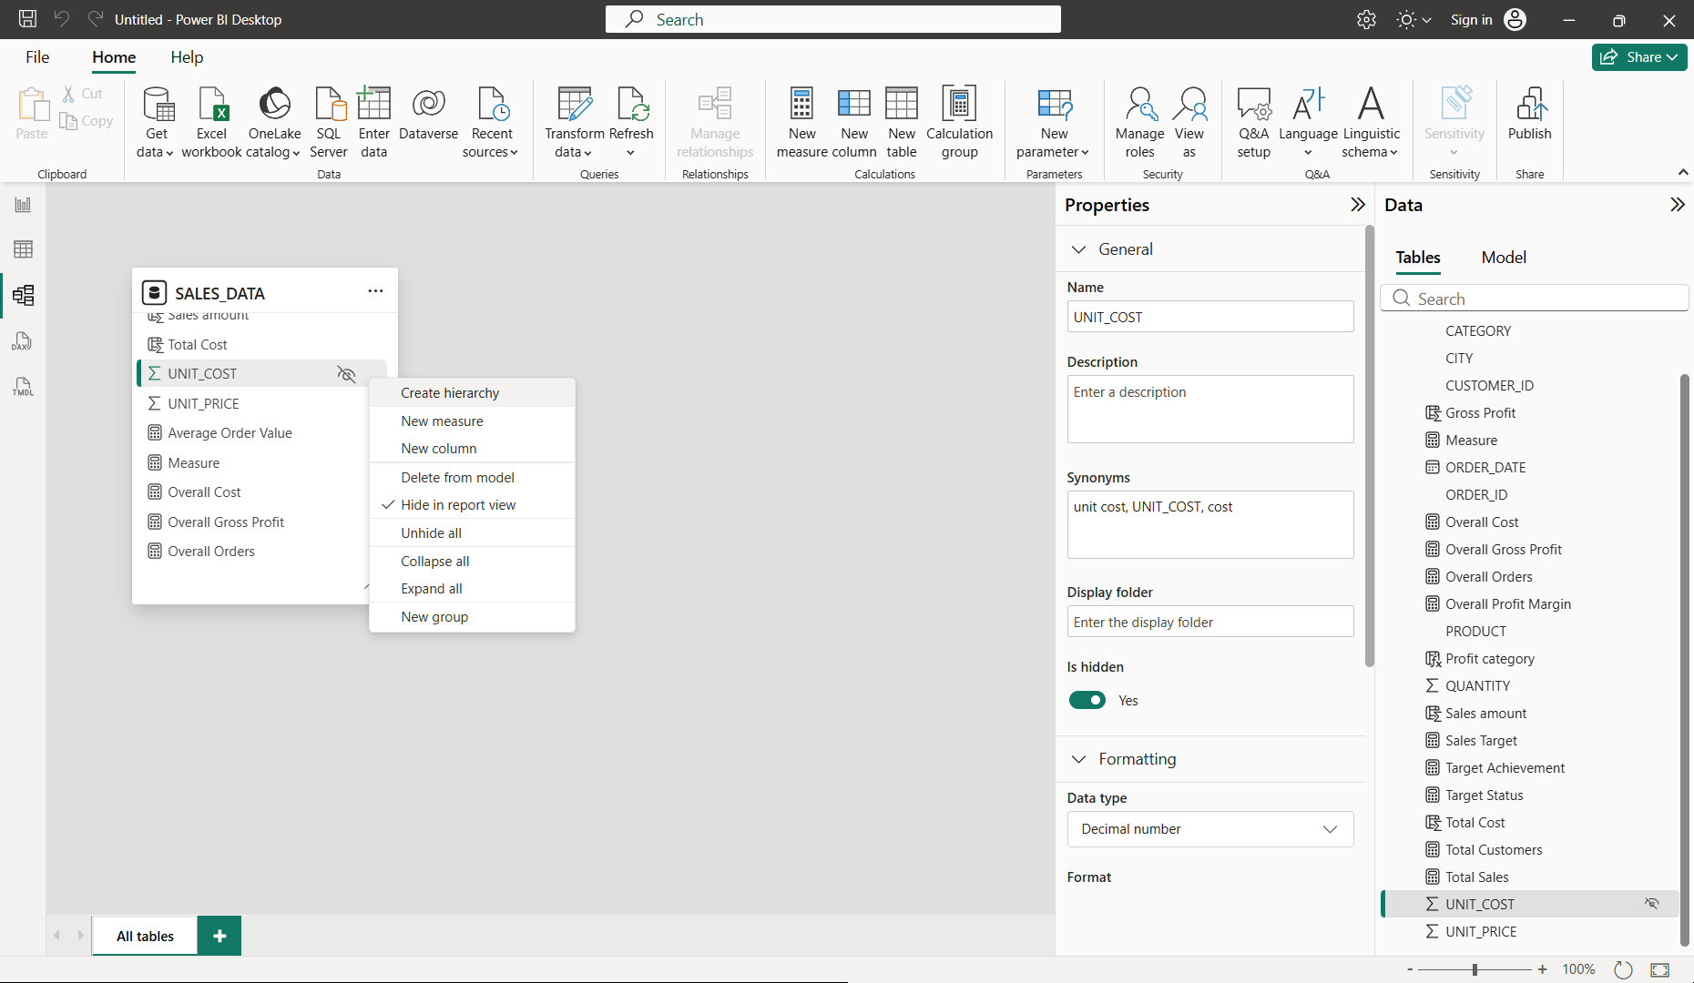

Performance analyzer:
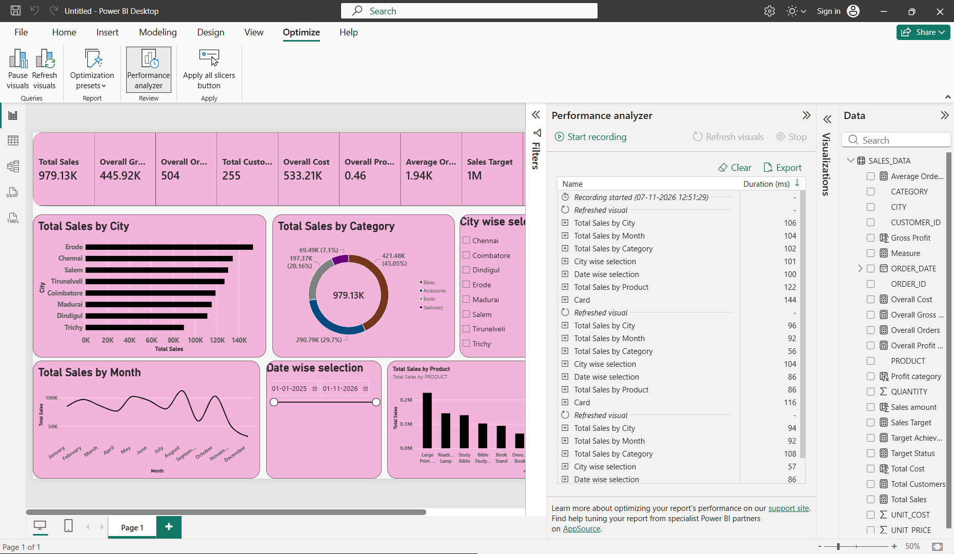
Overall Business Insights – Storytelling:
1. Observations:
- The business generated total sales of approximately ₹9.79 lakh from 504 orders and 255 unique customers.
- Erode is the highest revenue-generating city, while Trichy has the lowest sales.
- Bibles contribute the highest category-wise sales (43.05%), followed by Accessories (29.70%).
- Large Print Bible is the highest revenue-generating product, while Bookmark Set and Highlighter Pack have comparatively lower sales.
- The business achieved 97.91% of its ₹10 lakh sales target, with a gross profit of approximately ₹4.46 lakh.
2. Interpretations:
- The business has a good revenue base, but it is slightly below its expected sales target.
- Sales vary across cities, indicating differences in geographical demand and customer purchasing behaviour.
- Bibles and Accessories contribute significantly to revenue, showing stronger customer demand for these categories.
- Certain products generate more revenue than others, indicating differences in product popularity and purchasing patterns.
- Monthly sales fluctuations indicate that customer demand changes over time, making sales forecasting and inventory planning important.
3. Recommendations:
- Introduce promotional campaigns and customer engagement strategies to achieve the remaining sales target.
- Focus on marketing activities in low-performing cities while maintaining strong sales in high-performing cities.
- Maintain sufficient inventory of high-performing categories and introduce combo offers to improve lower-performing categories.
- Promote low-performing products through discounts and bundled offers while prioritizing high-demand products.
- Analyse monthly sales patterns, improve inventory planning and introduce customer loyalty programs to encourage repeat purchases.

